**Milestone 1: tables**

**Steps:**

**1.Open service now**

**2.Click on all > >search for tables**

**3.Select tables under system security**

**4.Click on new**

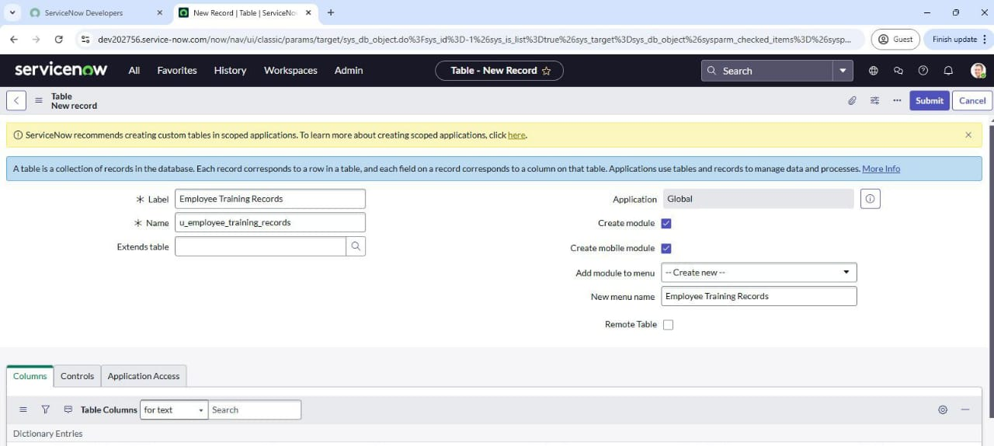**5.Fill the following details to create a new table**

**6.Add the following fields:**

**7.Training name (type: string)**

**8. Completion date (type: date)**

**9. Status (type : choice)**

**10. Employee ( type : reference),(reference field to system user table )**

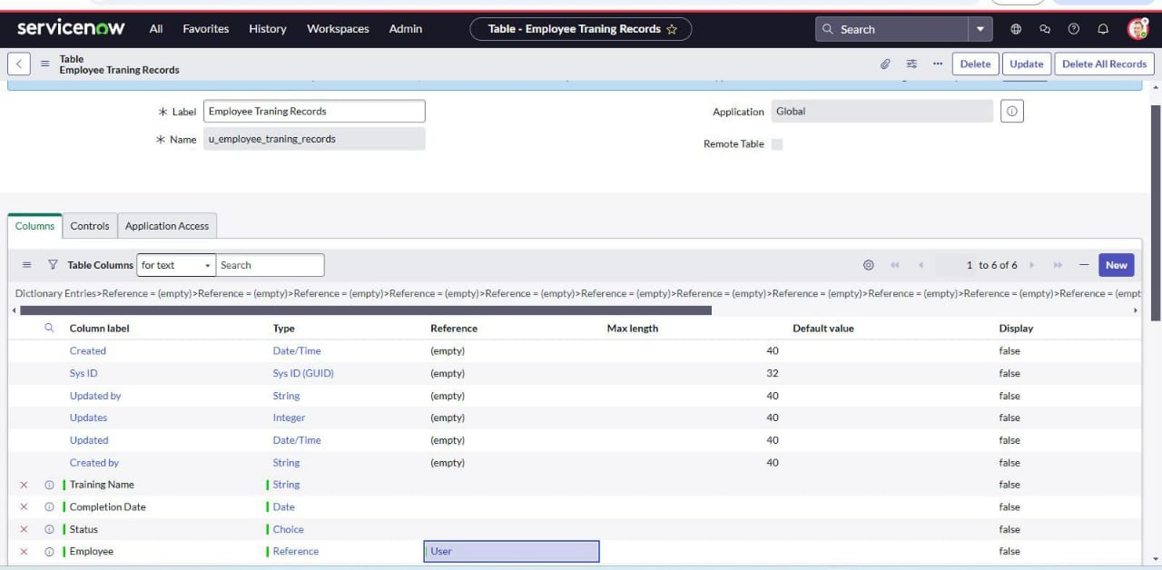

**11.Click on submit**

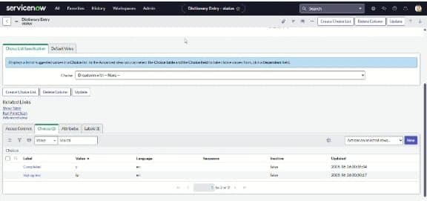**12. Click on choice and add to choices in the dictionary entry status**

**Milestone 2: import data**

**Steps**

**1. Open service now**

**2. Click on all > >search for system import s Select**

**3. Select load data and upload file that you have already created with four fields that are: (training name, completion date, status and employee)**

**4. Label: employee training**

**5. Name: u_employee_training**

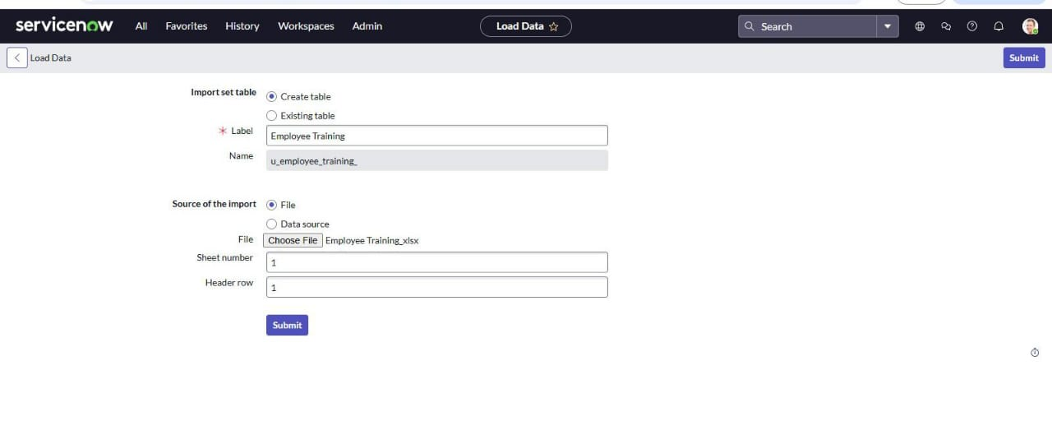

**6. Click to submit**

**MAP FIELDS:**

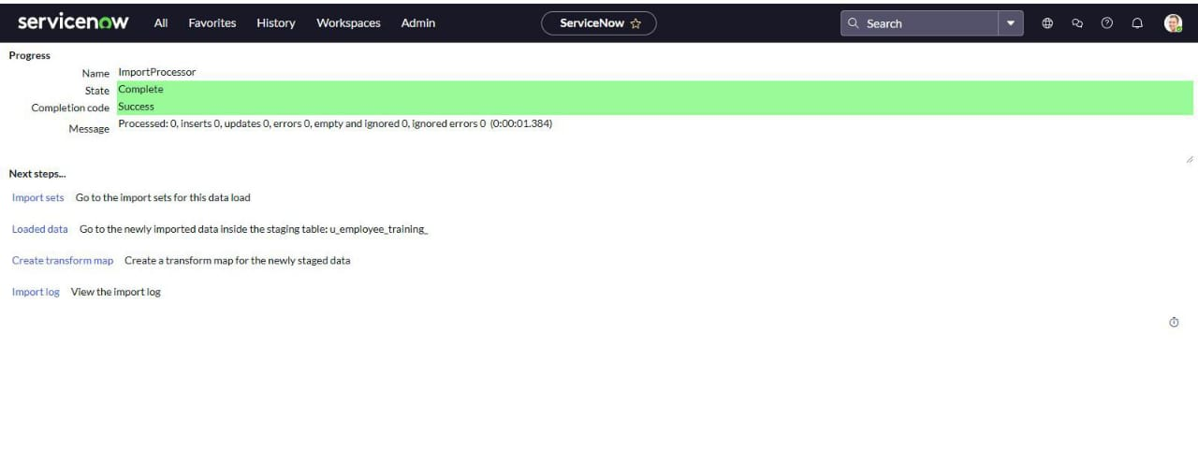

Steps:

1.Open service now

2.Click on all > > search for Transform maps

3.Fill the following details to create a new table

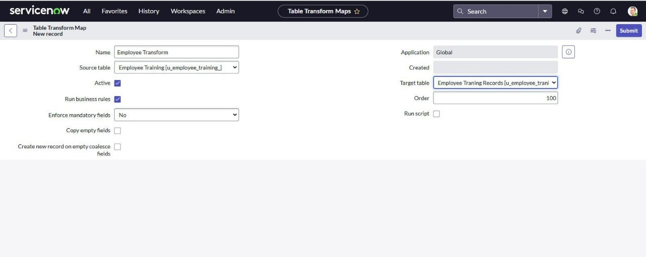

4. click on submit

5.add field maps as shown

6.click transform to run the import

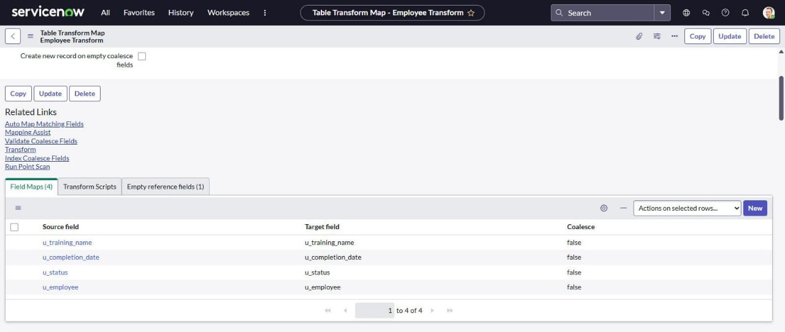

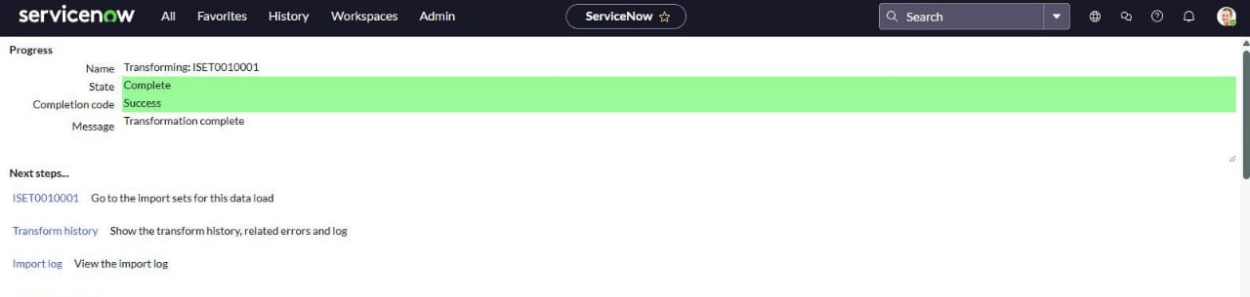7. Click transform to run the import

Milestone 3: using dot walking to access employee department information

Steps:

1.Open service now

2.Click on all >> system definition >>list layouts

3.Search for customer orders

4.Add the employee department field by using dot walking

5.Select the field and save changes

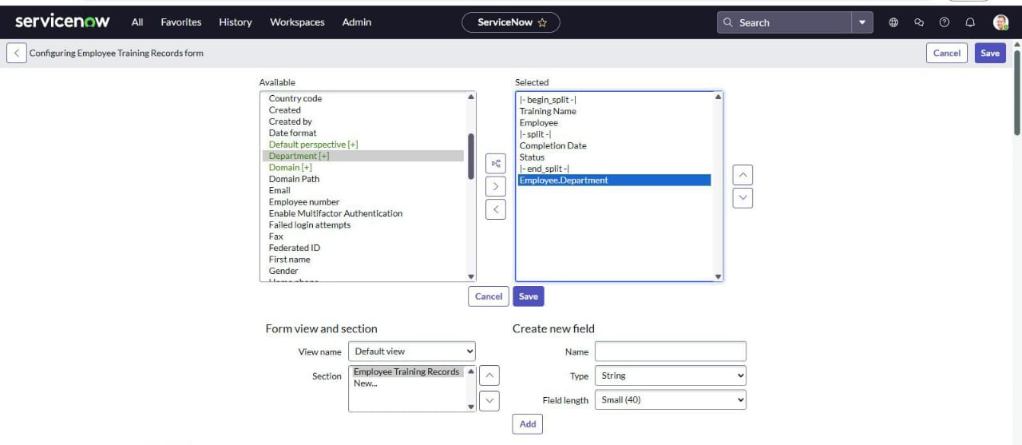 Milestone 4:Access control list (ACL)

Steps:

1.Open service now

2.Click on all>>ACL>>create new ACL

3.Define ACL (Employees)

4. Operation: Read

Milestone 5: Roles

Steps:

1.Open service now

2.Click on all>>roles>>create a new role:Hr manager

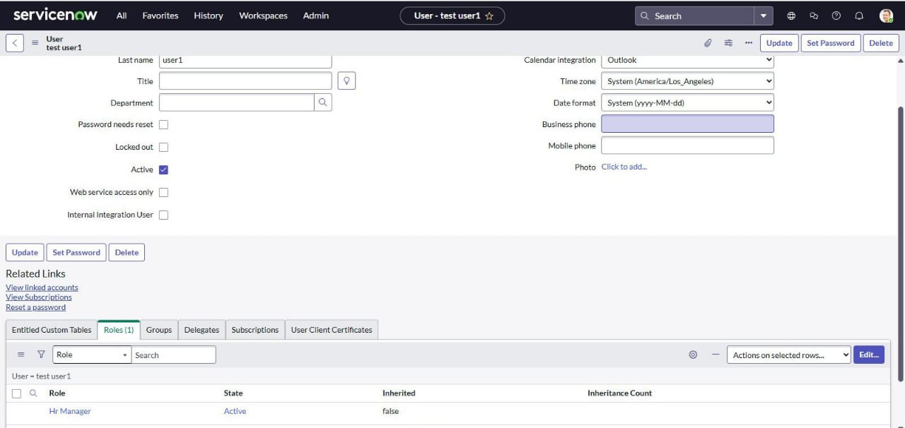3.Add in the sys_user

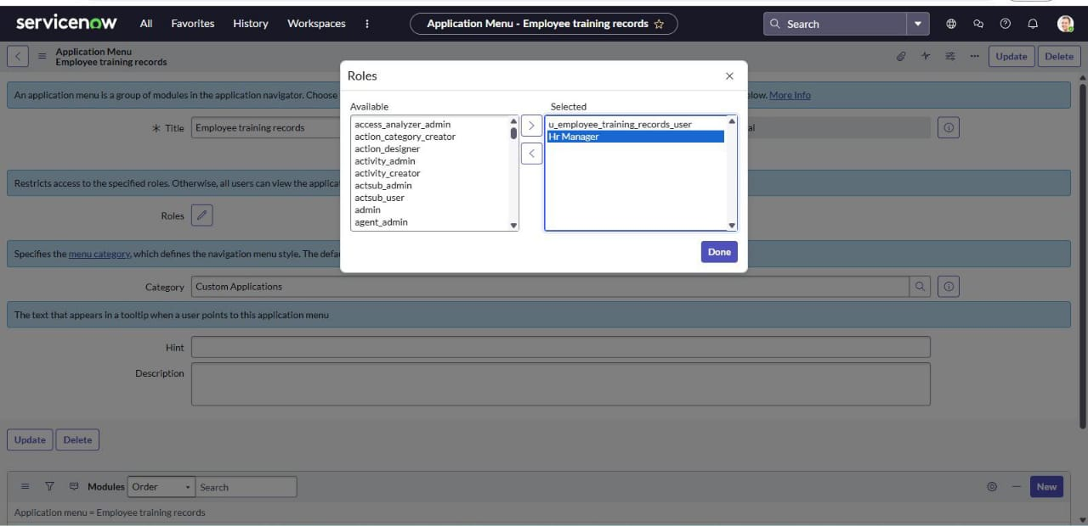4. Add this roll to the tables application and module

5. At the HR manager role to the sys_user

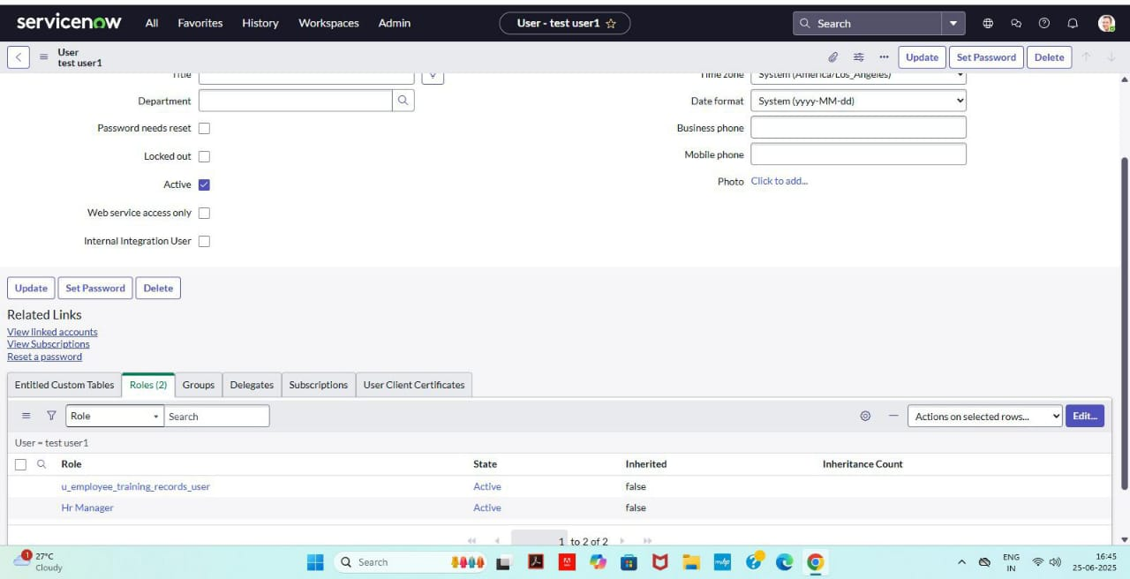

6. Now you can view each employees department information directly in the employee training records list view

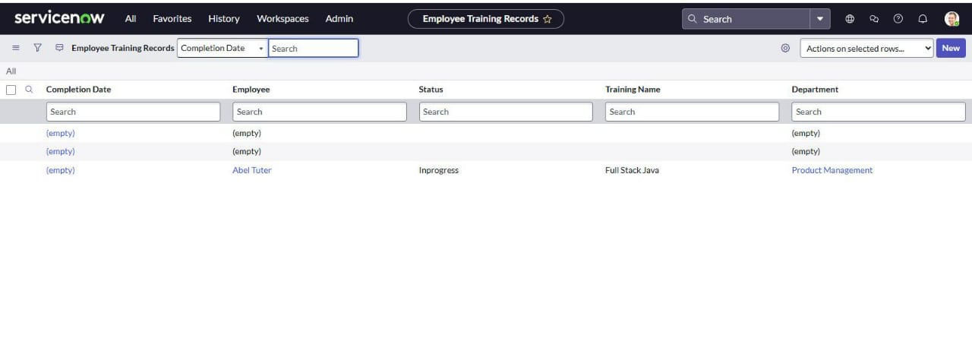

UPDATE TO ELEVATE ROLE :

Steps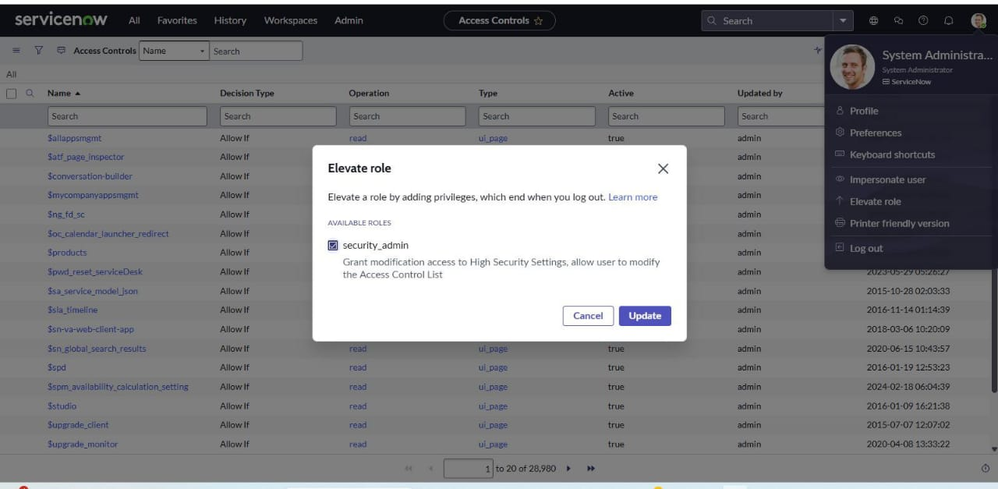 :

1. 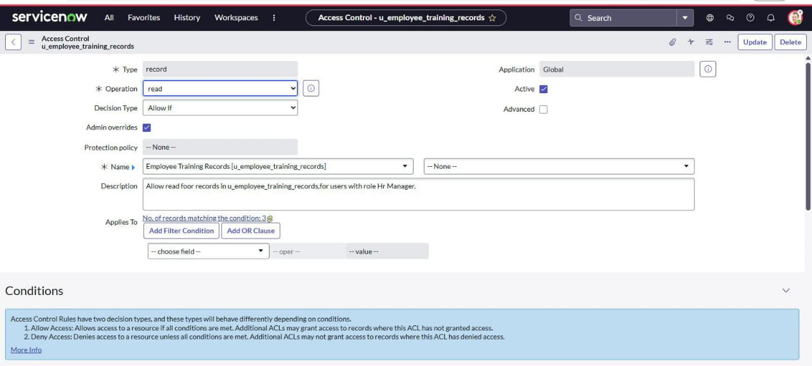Create new ACL and give read access to employee training record table
2. Give HR manager role to the ACL
3. Create another new ACL and repeat the same process to the write access

Milestone 6: result

Steps :

* 1. Impersonate the sys_ user and search employee training records
  2. 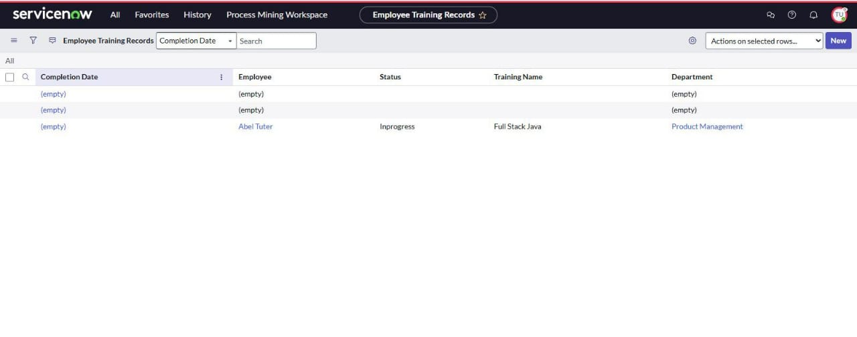Now you can see and edit the field

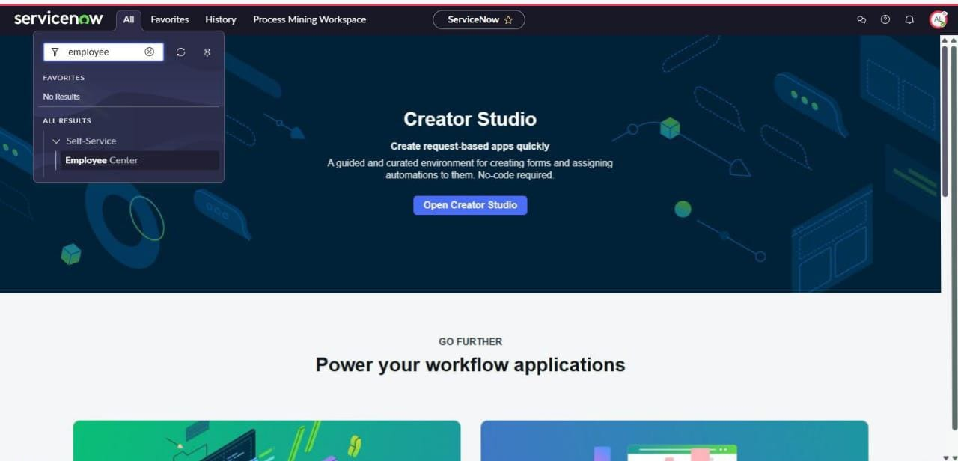3.Impersonate the other user you cannot see the table